**Beginning of the School Year, 2022.**

**Staff Prayer.**

*Friday, 28th January.*

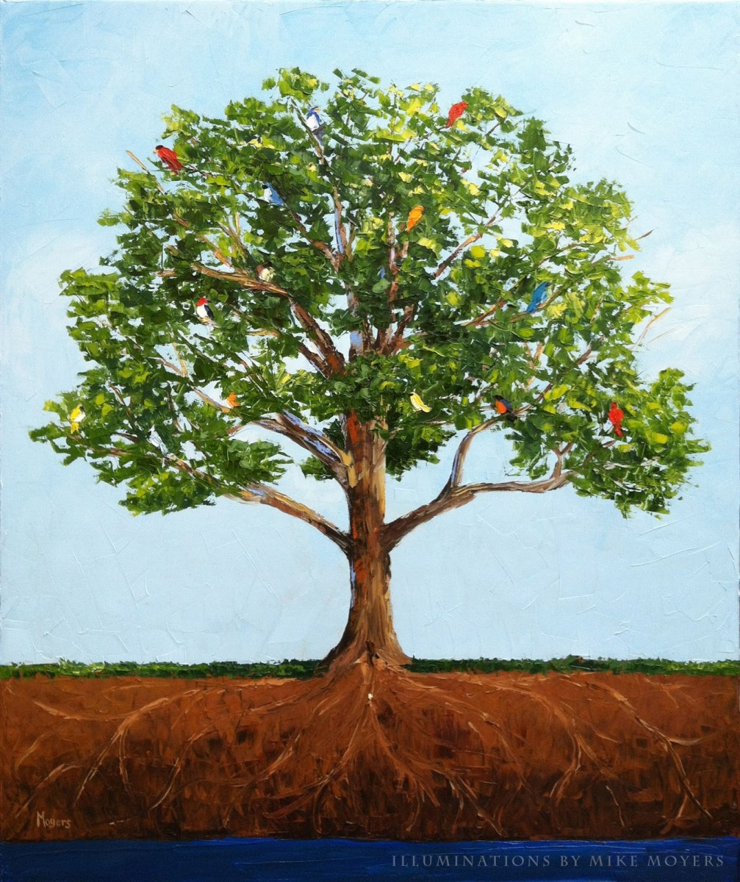

**Theme: Nurture and** Grow.

**Reading of the Day:** Mark 4:26-34

***Resources:***

* Prayer Focus Table and cloth - green for Ordinary Time, Year C.
* Bible - gospel marked (Mark 4:26-34).
* School Candle.
* Message Stick - to be held during Acknowledgement and Gospel.
* School Motto displayed - lettering on table.
* Soil and a large tree in a pot.
* Jars (one for each staff member) with 10 leaves inside (explanation included in prayer).

**We gather...**

***Introduction:***

Reader 1:

Today, we gather together to celebrate the beginning of the 2022 school year here at (name of school).

Take some time now to prepare to pray, to sit and to calm your inner self, to be in this moment.

*(pause for a few moments).*

Jesus said, “Where two or three are gathered in my name, I am there.”

So let us begin our prayer as we live our lives…

***Sign of the Cross:***

In the name of the Father and of the Son and of the Holy Spirit, Amen.

***Acknowledgement of Country:*** (can use this or own school’s Acknowledgement).

Reader 2:

We gather today on ******* country to continue our learning journey together.

We acknowledge Aboriginal and Torres Strait Islander people as the traditional custodians of the land upon which we meet.

We pay our respects to the Elders of the past, present and emerging and we acknowledge their spiritual connection to Country.

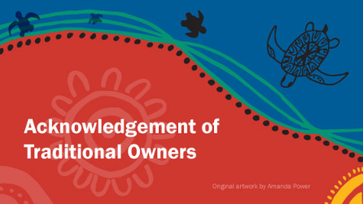

***Welcome:***

Reader 3:

As we gather to celebrate together, we look around and see familiar and new faces.

We welcome everyone with open hearts, with positive minds and with support and love.

The theme of our prayer today is based on today’s gospel reading of “The Mustard Seed.”

This seed is one of the smallest, yet the tree which grows from this seed is one of the largest.

Imagine for a moment that this seed is an impact you have on a child or staff member at our school. To you, it may seem small - a comment, a greeting, some attention. But to the receiver, it may be huge, just like a mustard tree.

Just as tall trees from tiny seeds can grow, so can **we** contribute to the lives of those around us - through small acts of kindness and love - making a difference so large we may not even recognise.

Reader 4:

Our prayer focus contains symbols of our prayer today, as well as our school motto.

This motto, ************ is a significant phrase made up of (number of) **small** words: (quote motto here or omit this paragraph).

As we participate in our prayer today, may we reflect on how we can:

* Allow our gifts to be shared.
* Be open to give and receive.
* Permit ourselves to excel in all we do.
* Have the courage to be outstanding.
* Grant everyone the opportunity to do and be their best.

(These statements are paraphrased versions of our school motto, “Let your light shine.” You may like to create your own or omit this paragraph, as suggested).

***Introduction:***

Reader 5:

Jesus’ words and actions in the gospel are central to all that we are and all that we do here at

******* (name of school).

In today’s gospel, we hear Jesus comparing the Kingdom of God to a mustard seed - the smallest of seeds (only 1 - 2mm) - which, when given the right conditions and care, grows into a tree that stands over three metres tall.

Together, let us pray:

*(words included in Powerpoint presentation for all to read).*

God of tiny seeds and giant trees, You take our lives and, with Your endless love, help us to produce acts of loving kindness for You each day in this world.

Enable us to let our light shine, knowing that You are always there for us.

Prepare our hearts to receive Your word and our spirits to respond in eagerness to serve You.

In Jesus’ name, we pray…

Amen.

Jean Bradbury: The Parable of the Mustard Seed

**We listen...**

***Gospel procession:***

(One staff member to collect the bible from the Prayer Focus Table and hold it while another staff member collects the Message Stick and holds it beside the priest/reader of the gospel).

***Gospel:*** *Mark 4:26-34 (copy at the end of this prayer).*

***Reader 6:*** A reading from the holy gospel according to Mark.

***All:*** Glory to you, O Lord.

***Reader 6:*** The gospel of the Lord.

***All:*** Praise to you, Lord Jesus Christ.

*(Priest or principal to address the staff, if appropriate).*

**We respond…**

Reader 7:

Our school Philosophy states that:

*************

(You may like to include your school’s Philosophy Statement here).

From this, our school Vision can become real.

**School Vision statements:**

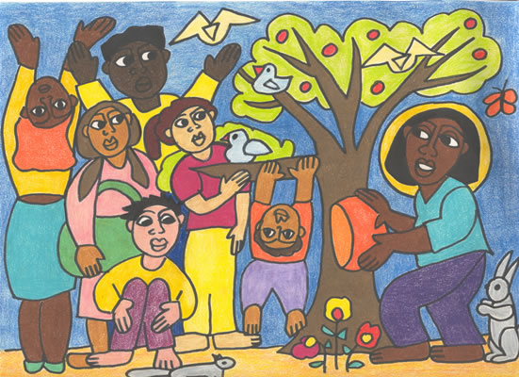Reader 8:

Our school Vision Statements emphasise that:

*************

(You may like to include your school’s Philosophy Statement here).

Reader 9:

With these beliefs in mind, together, let us pray:

*(words included in Powerpoint presentation for all to read).*

Lord,

We may not be able to confront queens or challenge presidents;

We may not have the capacity to divert resources, or uplift communities;

We may not have the voice to silence the noise of war, or the words to negotiate peace between armies;

But, as we follow you, O Christ, we are able to do something.

And so, we pray that you would inspire us to commit to and act on the small difference we can make:

May we bring peace through small acts of gentleness and reconciliation.

May we bring wealth through small contributions and collaborations.

May we bring safety through small acts of consideration and acceptance.

May we bring wholeness through small acts of care and service.

And, in these small ways, O God, may our small differences make a big contribution to our world.

Amen.

(Written by John van de Laar. Posted on Sacredise. [http://sacredise.com](http://sacredicse.com))

**We act…**

**Final blessing**:

Reader 10:

Let us bow our heads and pray for God’s blessing for ourselves in this new school year.

God, who gathers us and unites us, we give you thanks for drawing us together in this community.

May we remember that each mustard seed we plant and nurture through our kind words and positive actions has the potential to grow into one of the world’s largest trees.

May we offer love, safety and a sense of belonging for those in our care.

This we ask in Jesus’ name.

Amen.

**Song:** [**“The Mustard Seed”**](https://www.youtube.com/watch?v=PxCa7aV0RcA) **by Andrew Chinn and Drew Lane.**

Reader 11:

Together we end our prayer,

In the name of the Father, and of the Son and of the Holy Spirit,

Amen.

I would like to now invite you to come forward to collect a small jar from our prayer focus table.

Inside each jar, there are ten blank leaves and a scattering of mustard seeds..

Throughout the year, you are invited to recognise and record the “mustard seeds” in your life.

These may be acts of kindness you receive from others or kind words you hear;

actions you receive or actions that you give; actions that, in the words of Andrew Chinn, help to “nurture” others and “water” others, giving peace.

purposeful ways that you see people encouraging others to grow and be their best.

The leaves may record a word, an action, a name - it is up to you.(the leaves are not very big!!!)

At the end of the year, we will use these leaves as part of our final staff prayer together - to witness our own “mustard tree” - to recognise and celebrate our growth.

Thank you for participating in our prayer today!!

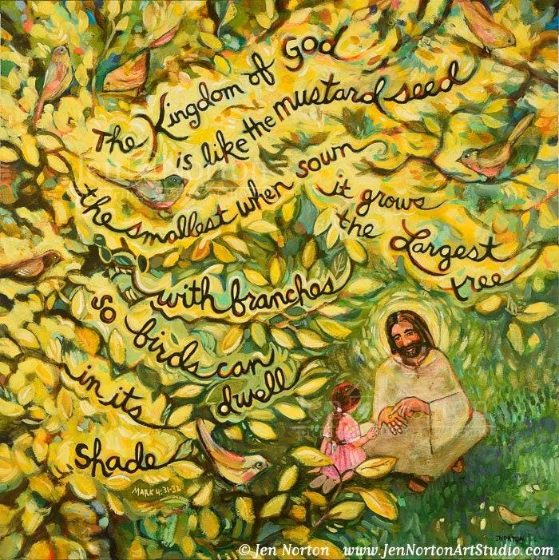

**Gospel reading of the day: Mark 4:26-34**

A reading from the holy gospel according to Mark.

Jesus said, “The kingdom of God is as if someone would scatter seed on the ground, and would sleep and rise night and day, and the seed would sprout and grow, he does not know how.

The earth produces of itself, first the stalk, then the head, then the full grain in the head. But when the grain is ripe, at once he goes in with his sickle, because the harvest has come.”

He also said, “With what can we compare the kingdom of God, or what parable will we use for it?

It is like a mustard seed, which, when sown upon the ground, is the smallest of all the seeds on earth; yet when it is sown it grows up and becomes the greatest of all shrubs, and puts forth large branches, so that the birds of the air can make nests in its shade.”

With many such parables he spoke the word to them, as they were able to hear it; he did not speak to them except in parables, but he explained everything in private to his disciples.

The gospel of the Lord.