Stations of the Cross
Prayer Reflection Script
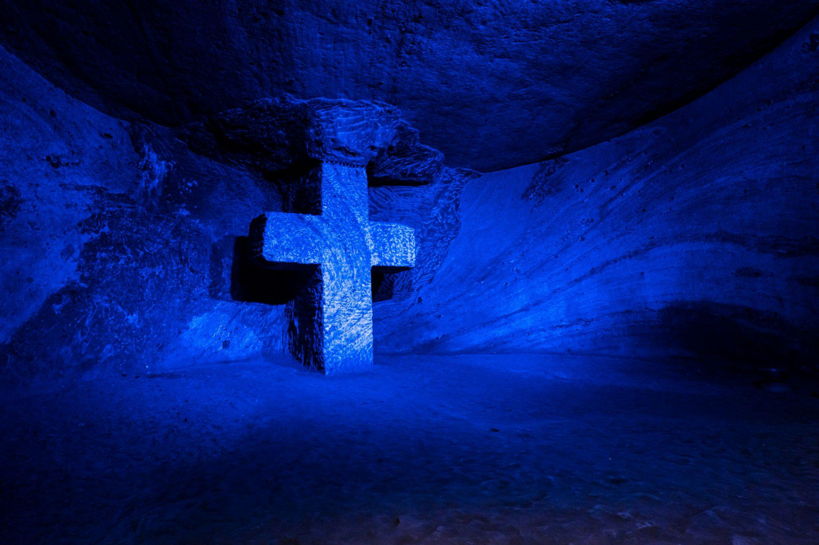

Acknowledgement of Country.
Reader 1:
We gather today on *** country to continue our learning journey together.
We acknowledge Aboriginal and Torres Strait Islander people as the traditional custodians on the land upon which we meet.
We pay our respects to the Elders of the past, present and emerging and we acknowledge their spiritual connection to Country.

Introduction.
Reader 2:
The Stations of the Cross can be found on display in many churches throughout the world, from older paintings and wood carvings to more modern artworks made from metal or stone.
These fourteen Stations tell us of the last days of Jesus’ life here on Earth.
They tell us of Jesus’ love for us.
They tell us of God’s’ love for us.

Reader 3:
Following the Stations of the Cross offers us a powerful way to pray, a personal way to reflect, and a community way to remember.
So let us begin our prayer as we live our lives,
In the name of the Father and of the Son and of the Holy Spirit, Amen.
Opening prayer:
Reader 4:
God our Father, who loves us all, be with us as we pray.
Help us see the love you showed others through Jesus, your Son, when he was here on Earth.
Help us be that love for others today and always.
May the Holy Spirit guide us in love.
We ask this prayer through Christ our Lord,
Amen.

First Station: Jesus is condemned to death.
Based on Mark 15:1-5, 15
Reader 5:
The first station - Jesus is condemned to death.
It was morning.
The chief priests, the elders and scribes, and the whole council took Jesus to Pilate.
Pilate asked, “Are you the King of the Jews?”
Jesus answered “You have said so.”
They accused Jesus of many things.
Pilate again asked him, “Have you no answer to make?”
But Jesus did not answer.
So Pilate delivered Jesus to be crucified.

Response: “We Remember: The First Station. Jesus is condemned to death.” by Drew Lane

Second Station: Jesus carries his cross.
Based on John 19:6, 15-17
Reader 6:
The second station - Jesus carries his cross.
The crowd shouted “Crucify him, crucify him!”
Pilate said, “I find no crime in him.”
They cried out, “Away with him, away with him, crucify him!”
Pilate said, “Shall I crucify your King?”
They answered, “We have no king but Caesar.”
They took Jesus and made him carry his own cross to the place called Golgotha, the place of the skull.

Response: “We Remember: The Second Station. Jesus carries his cross.” by Drew Lane

Third Station: Jesus falls for the first time.
Based on John 19:1-3
Reader 7:
The third station - Jesus falls for the first time.
The soldiers plaited a crown of thorns, and put it on Jesus' head.
They wrapped a purple robe around him.
They came up to him, saying, “Hail, King of the Jews!” and made fun of him.
Jesus fell.

Response: “We Remember: The Third Station. Jesus falls for the first time.” by Drew Lane

Fourth Station: Jesus meets his mother.
Based on Luke 2: 34-35
Reader 8:
The fourth station - Jesus meets his mother.
When Mary saw Jesus, she remembered the special words said to her by Simeon when Jesus was a baby:
“This child is destined for the falling and the rising of many in Israel.
He will be a sign that will be opposed so that the inner thoughts of many will be revealed.
And your heart will be broken.”

Response: “We Remember: The Fourth Station. Jesus meets his mother.” by Drew Lane

Fifth Station: Simon of Cyrene helps Jesus carry the cross.
Based on Mark 15:21
Reader 9:
The fifth station - Simon of Cyrene helps Jesus carry the cross.
The soldiers made a man, who was coming in from the country, help Jesus to carry his cross.
It was Simon of Cyrene.

Response: “We Remember: The Fifth Station. Simon of Cyrene bears the cross.” by Drew Lane

Sixth Station: Veronica wipes the face of Jesus.
Based on Isaiah 53:2-3
Reader 10:
The sixth station - Veronica wipes the face of Jesus.
He was hated and rejected.
A man of sorrow, and grief.
People hid their faces, not wanting to help.
He was despised.
But Veronica saw his pain and wiped his face.

Response: “We Remember: The Sixth Station. Veronica wipes the face of Jesus.” by D Lane

Seventh Station: Jesus falls the second time.
Based on Romans 8:31-32; 38-39
Reader 11:
The seventh station - Jesus falls the second time.
If God is for us, who is against us?
God did not spare his own Son but gave him up for us all.
Nothing will be able to separate us from the love of God.

Response: “We Remember: The Seventh Station. Jesus falls the second time.” by Drew Lane

Eighth Station: Jesus meets the women of Jerusalem.
Based on Luke 23:27-31
Reader 12:
The eighth station - Jesus meets the women of Jerusalem.
There were many people following Jesus as he carried his cross.
A group of women from Jerusalem saw Jesus and cried out loudly.
Jesus said, “Do not cry for me but cry for yourselves and your children.”

Response: “We Remember: The Eighth Station. Jesus meets the women of Jerusalem.” by Drew Lane

Ninth Station: Jesus falls a third time.
Based on Psalm 38:4-9
Reader 13:
The ninth station - Jesus falls a third time.
I am utterly spent and crushed.
I groan because of the pain in my heart.
God, all my longing is known to you,
my sighing is not hidden from you.
My heart throbs, my strength fails me;
and the light of my eyes—it also has gone from me.
My friends and companions stand away from me.
But it is for you, O Lord, that I wait.

Response: “We Remember: The Ninth Station. Jesus falls for the third time.” by Drew Lane

Tenth Station: Jesus' clothes are taken away.
Based on John 19:23-24
Reader 14:
The tenth station - Jesus' clothes are taken away.
The soldiers took Jesus’ clothes and divided them between themselves.
Jesus’ tunic was woven from top to bottom and hard to tear.
They said, “Let us roll dice to see whose it shall be.”

Response: “We Remember: The Tenth Station. Jesus' clothes are taken away.” by Drew Lane

Eleventh Station: Jesus is nailed to the cross.
Based on Luke 23:33-34
Reader 15:
The eleventh station - Jesus is nailed to the cross.
They came to the place called The Skull.
There they crucified Jesus.
They crucified two criminals with him, one on the right and one on the left.
Jesus said, “Father, forgive them; for they know not what they do.”

Response: “We Remember: The Eleventh Station. Jesus is nailed to the cross.” by Drew Lane

Twelfth Station: Jesus dies on the cross.
Based on Luke 23:44-46
Reader 16:
The twelfth station - Jesus dies on the cross.
It was now about the sixth hour.
There was darkness over the whole land until the ninth hour.
Then Jesus cried out loudly, “Father, into thy hands I commit my spirit!”
Having said this, he breathed his last.

Response: “We Remember: The Twelfth Station. Jesus dies on the cross.” by Drew Lane

Thirteenth Station: Jesus is taken down from the cross.
Based on Luke 23:44-46
Reader 17:
The thirteenth station - Jesus is taken down from the cross.
It was evening.
There was a rich man from Arimathea, named Joseph.
He went to Pilate and asked for the body of Jesus.
Pilate ordered it to be given to him.
Joseph of Arimathea took the body from the cross and wrapped it in a clean linen cloth.

Response: “We Remember: The Thirteenth Station. Jesus is taken down from the cross.” by Drew Lane

Fourteenth Station: Jesus is laid in the tomb.
Based on John 19:38-40
Reader 18:
The fourteenth station - Jesus is laid in the tomb.
Joseph of Arimathea took Jesus’ body from the cross.
A man called Nicodemus helped Joseph.
They took the body of Jesus, and wrapped it in linen cloth with spices.
They placed Jesus’ body in the tomb.
A great stone was rolled into place in the doorway of the tomb and then they left.

Response: “We Remember: The Fourteenth Station. Jesus is laid in the tomb.” by Drew Lane

Reader 18:
These fourteen Stations tell us of the last days of Jesus’ life here on Earth.
They tell us of Jesus’ love for us.
They tell us of God’s’ love for us.
Let us go and share that love with others.
We end our prayer by making the Sign of the Cross.
In the name of the Father and of the Son and of the Holy Spirit,
Amen.

Students and staff leave the gathering space silently, to the soft banging of a drum or…
We Are Waiting
OR
Use “The Stone’s Been Rolled Away” by Drew Lane to celebrate the Resurrection.

