# Butterfly Music/Butterfly House

[*www.butterflyhouse.online*](http://www.butterflyhouse.online)

[*www.butterflymusic.com.au*](http://www.butterflymusic.com.au)

[*andrew@butterflymusic.com.au*](mailto:andrew@butterflymusic.com.au)

##### *PO Box 190 UNANDERRA NSW 2526*

*Ph: 0413 086 990*

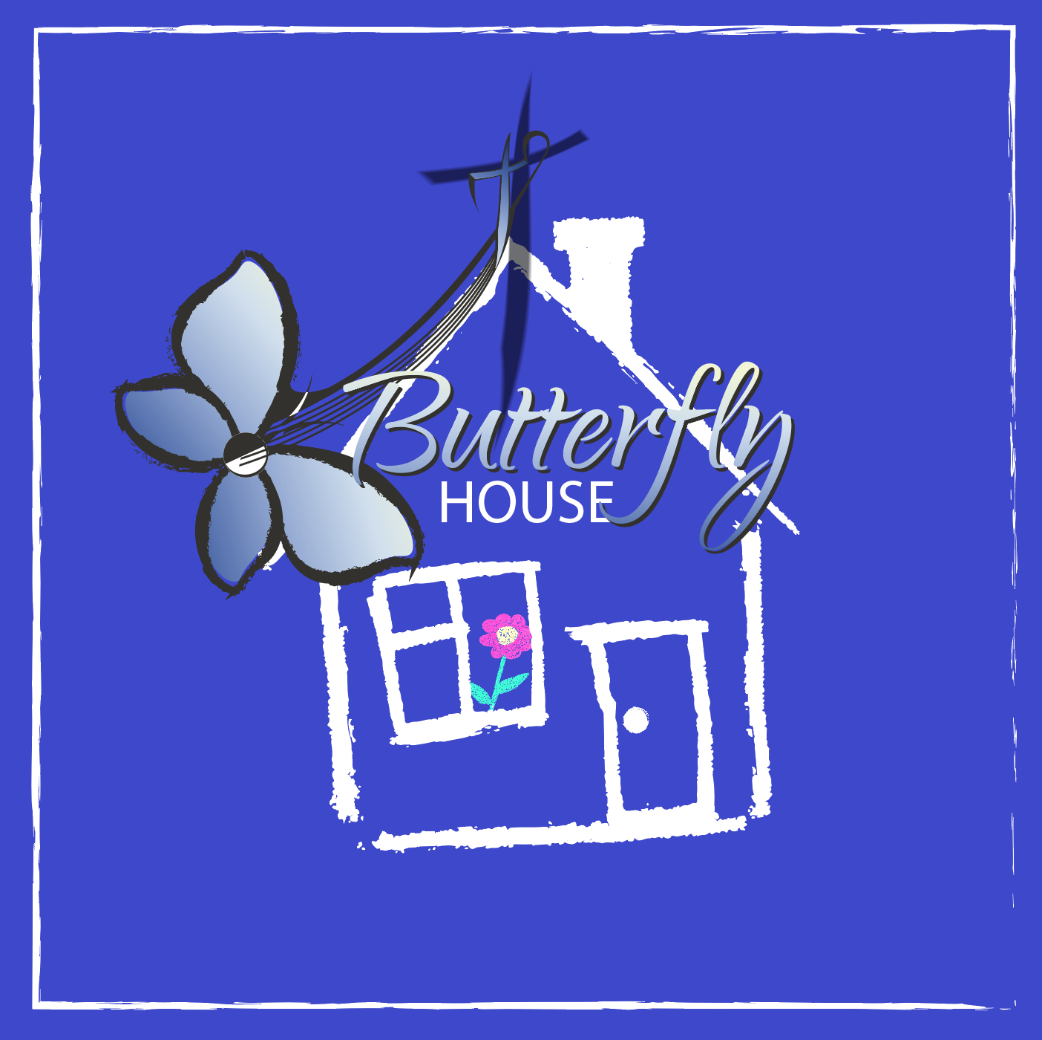

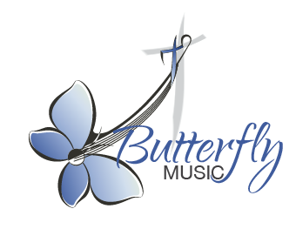

# Andrew Chinn: School and Family Concerts

##### Expression of Interest

**Name of School:**

**Street Address: State:**

**Contact Person:**

**Phone Number(s):**

*(Please include a mobile or after hours contact number, if possible)*

**Best time to call:**

**Email address:**

**Preferred dates:**

**Number of students in school:**

**Venue and its capacity:**

**Class groupings:**

(i.e., how many of each class and how are your classes grouped: grades, stages)

**School Bell times:** (e.g. 9-11, 11:30-1:00, 1:45-3:00)

**Morning session Middle session Afternoon session:**

**Preferred Option: please circle**

1. **General RE Theme: Daytime Workshops, afternoon concert**
2. **Journey Through Bible In Song: Daytime Workshops, afternoon concert**
3. **Short program: Choir workshop followed by whole school concert (depending on availability and school size)**
4. **Holy Week Remembrance: Sydney, Wollongong, Parramatta and Broken Bay Schools only**