Butterfly Music/Butterfly House
www.butterflyhouse.online
www.butterflymusic.com.au
drewlane@butterflymusic.com.au

PO Box 190 UNANDERRA NSW 2526
Ph: 0413 086 990

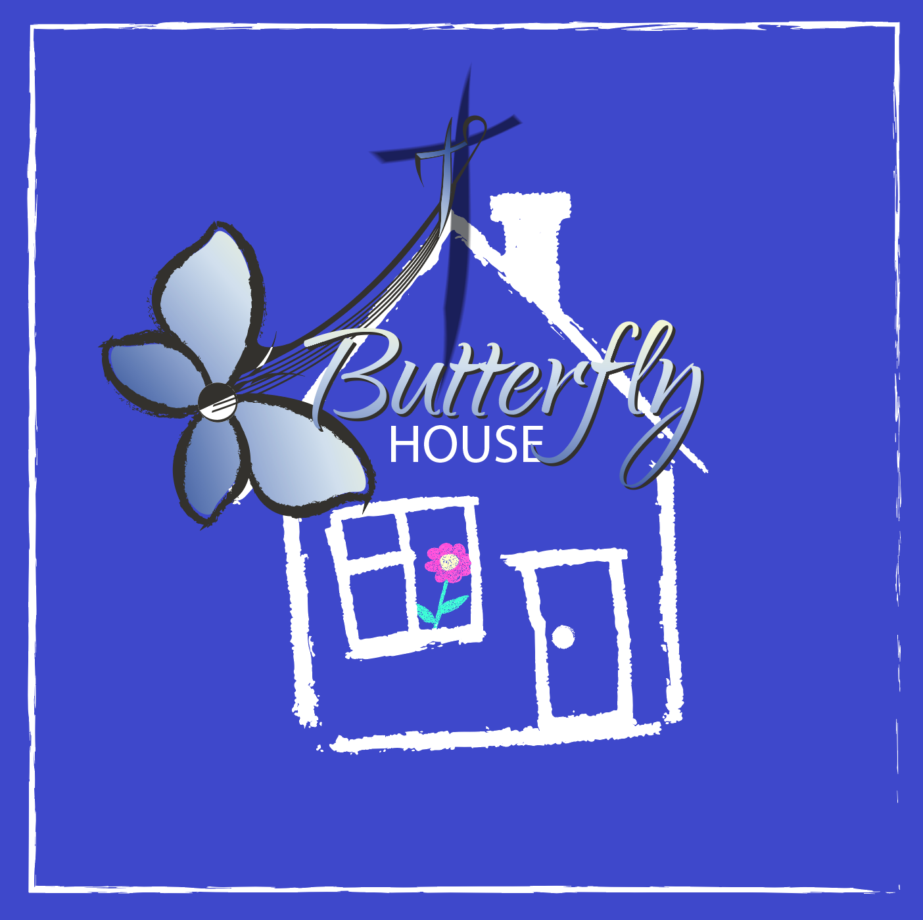
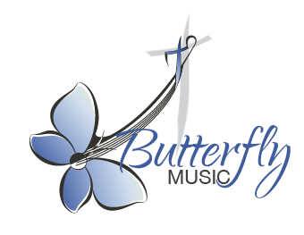

Drew Lane: School and Family Concerts

Expression of Interest

Name of School:
Street Address: State:
Contact Person:
Phone Number(s):
(Please include a mobile or after hours contact number, if possible)
Best time to call:
Email address:
Preferred dates:
Number of students in school:
Venue and its capacity:
Class groupings:
(i.e., how many of each class and how are your classes grouped: grades, stages)
School Bell times: (e.g. 9-11, 11:30-1:00, 1:45-3:00)
Morning session:
Middle session:
Afternoon session:

Preferred Option: please circle
- General RE Theme: Daytime Workshops, afternoon concert
- Short program: Choir workshop followed by whole school concert (depending on availability and school size)
- Holy Week Remembrance: VIC schools only- LIMITED
- Advent/Christmas Concerts: VIC and NSW- LIMITED

